

California State University, East Bay

**MGMT 616_01**

People Analytics

**Creativity and HR Practices**

Submitted by:

**Team 9:**

Kishore & other teammates

Submission date: November 22, 2019

Table of Contents

Executive Summary 3

Case Background 4

Factor Analysis 7

Regression Analysis 10

Recommendations 11

Appendices 12

# Executive Summary

# An internal survey was conducted with the staff at a nursing home facility. The participants included various types of administrative, medical practitioners, coordinators, supervisors and managers. Besides the traditional demographic questions, the survey consisted of various questions that fell into a pattern (construct). Our team objectives were to analyze the survey questions to determine if they were appropriate measures, use Factor Analysis to determine the distinct factors and if they are inherently different. We also ran a regression analysis to determine if/what one factor enhances the other.

# Our preliminary review of the survey measures concluded that the items were consistent with what we’re trying to measure. However, we did recommend a few changes to the variable names to improve the survey’s consistency, quality of responses and improve the user’s interpretation. With regards to Factor Analysis, we identified two distinct factors and their sub dimensions based on how their respective items loaded in the factors. We identified them as follows:

# 

With these factors, we were able to run a regression analysis to determine if any of the HR Practice factors enhanced any of the Creativity factors. Our findings concluded that, of our four hypothesis tests ran, the Supervisor/Employee Engagement and Meetings had a significant influence on the Patient Experience because the P-Value of .02 was less than the alpha of 0.5.

From the results of our study findings, we’re able to present various internal recommendations (*to the management staff, HR & public policy officials and the nursing home staff*) that would continue to improve and implement the organization’s creative processes.

# Case Background

An all-staff survey was conducted with staff at a nursing facility; the surveyed participants were a wide-range of staff that included various types of nurses, therapists, administrative support, staff coordinators and managers. The initial survey also had wide-ranging questions that measured various implied constructs (questions that fall in to a particular pattern). Of these predetermined constructs, our team was assigned to analyze the Creativity and HR Practices constructs. The Creativity survey questions asked participants to rate their performance efforts relative to their coworkers. On the other hand, the HR Practices questions asked participants about their thoughts on their unit leadership (***See Appendix A***). During our initial team discussion, we determined our objectives would be:

1. *Determine if our construct survey questions and demographic variable measured are appropriate measures for our analysis.*
2. *Our team will use Factor Analysis to determine the distinct Creativity and HR Practices factors. The Factor Analysis will also help us determine if the Creativity and HR Practices factors are inherently different.*
3. *We’ll run a Regression Analysis to determine if, or what, HR Practices factors enhance Creativity amongst the staff surveyed.*

**Initial Review**

We felt the overall structure of the survey questions were on par with what we were seeking to analyze. However, to improve structural consistency and clarity within the demographic variables measured, we recommend a few changes to the original Demographic Survey Coding (***Table 1***). For example, we would use a prefix like “EMP” to better identify questions and lead the participant during the survey.

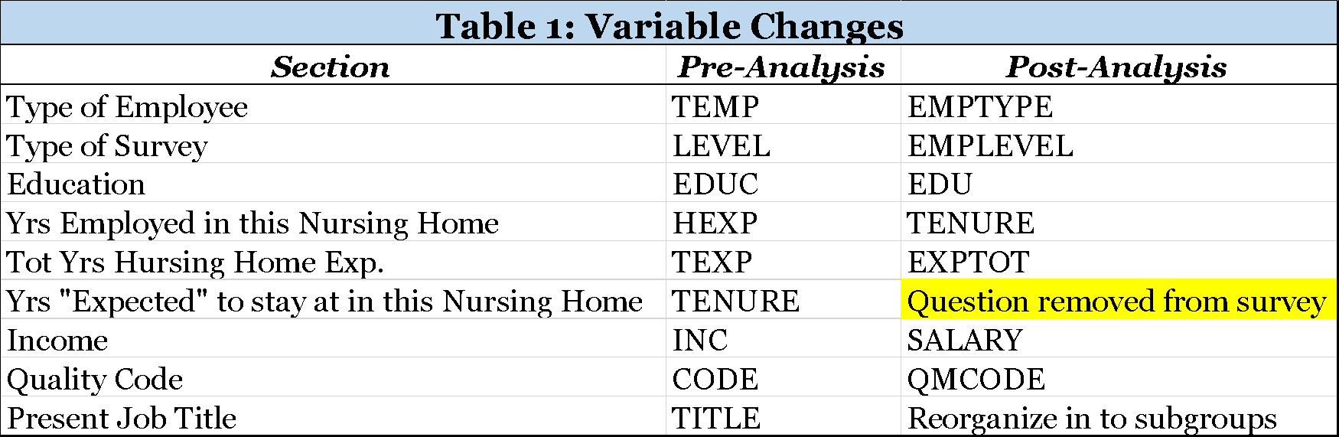

Also, we would create subgroups in the “EMPTYPE” because the current scale had 20 possible answers (***Table 2***). We felt that many of the employee types were very similar and/or redundant; consolidating them in to five subgroups could provide us an appropriate sample size for each response to replicate the statistical sample and determine a statistical significance. Finally, if we had to remove an item, it would be the original “TENURE” question. We felt this question was too subjective and open-ended. Once again the responses would be so varied that we would not be able to use this question in our analysis. Perhaps if we used an ordinal scale (*in years*) like 0-1, 1-2, 3-4, 4-5, and 5+, we could better capture and quantify the responses. Overall, we felt that many of our recommendations were cosmetic, but we think these changes would fall in line with a more traditional industry survey and provide the end-user a better interpretation of the demographic variables measured.

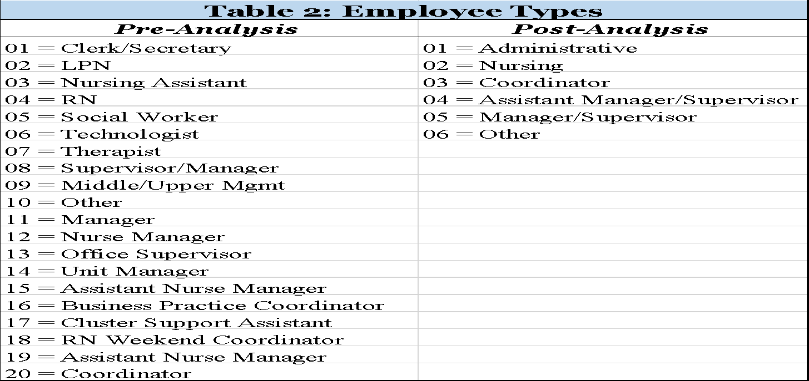

**Preliminary Assumptions/Hypothesis**

Our team’s preliminary assumptions are that the current HR Practices do in fact have a positive impact on implementing creative business practices at the nursing home facility and industry.

**Profile Samples**

In order to validate our study findings, our team took a slightly different approach to developing profile samples. Because we determined the overall sample size of 164 participants was too small, we developed “potential” profiles that may provide some validity to our study findings. Once again, these profiles were determined before analysis, but here are just a few:

1. Do coordinators or managers feel they are most creative with implementing innovative business strategies?
2. Do Front Line employees or Managers feel they respond in creative ways to address patient needs?
3. Which job titles/departments do supervisors and employees engage in meetings to discuss patient needs?

Upon the completion of our analysis, we will determine if, and/or what, factors are Enhanced by the other. In the scenario above, if we should determine that HR Practices influence Creativity and Innovation, we can analyze our results to determine which specific positions benefited from supervisor/employee meetings leading to creative business practices. Also, once our objective data is defined, our follow-up survey questions could be developed accordingly.

# Factor Analysis

Exploratory Factor Analysis is conducted to discover what latent variables are behind a set of variables or measures. On the other hand, Confirmatory Factor Analysis is conducted to test theories and hypotheses about the factors or latent variables one expects to find. The key difference between the two is that we’ve specified our measurement model before we’ve looked at our data based on theory. In this case, the number of factors are four and we have a firm idea on how the latent variables will load into the factors. Therefore, we use the confirmatory approach and determine the factors using principle axis method.

According to the case given to us, Creativity and HR practices have two factors each. As expected, the output obtained from the factor analysis had four factors. We used Factor Reduction to eliminate items which were similar i.e. highly correlating with each other and running the Factor Reduction process by individually removing the items with a factor loading of less than 0.7. The final Factor pattern matrices (***Creativity Table 3 & HR Factors Table 5***) and its corresponding correlation matrices (***Creativity Table 4 and HR Practices Table 6***) obtained are shown below:

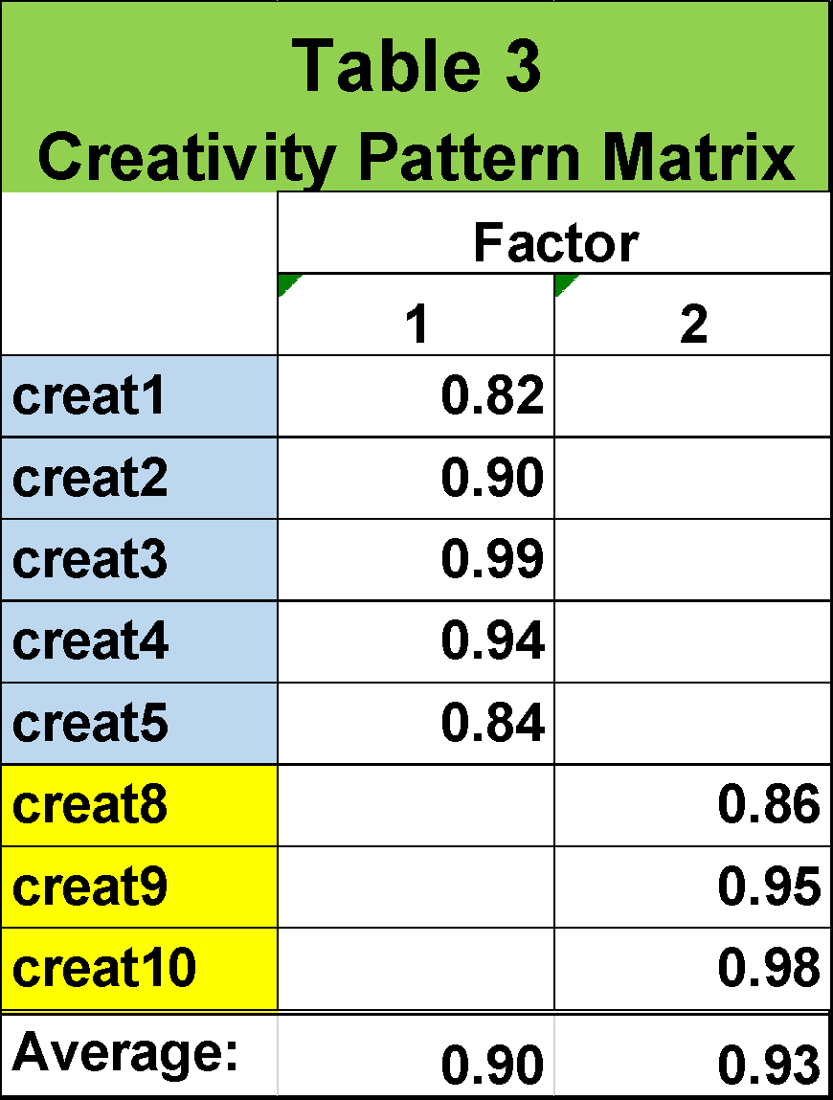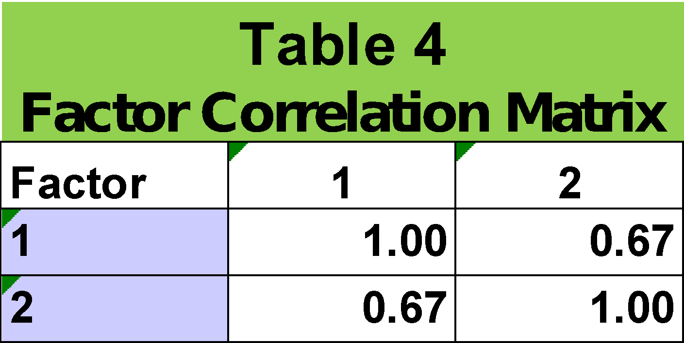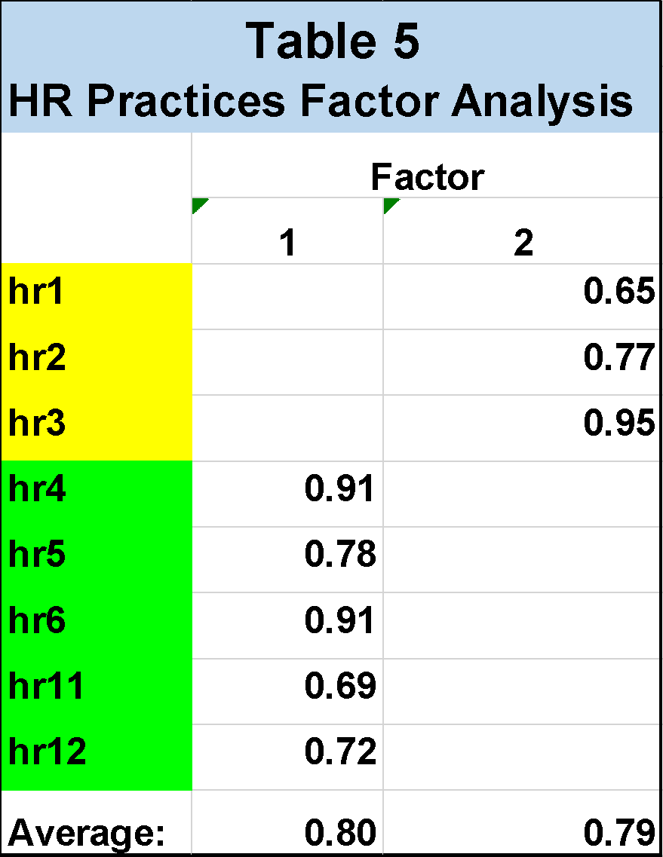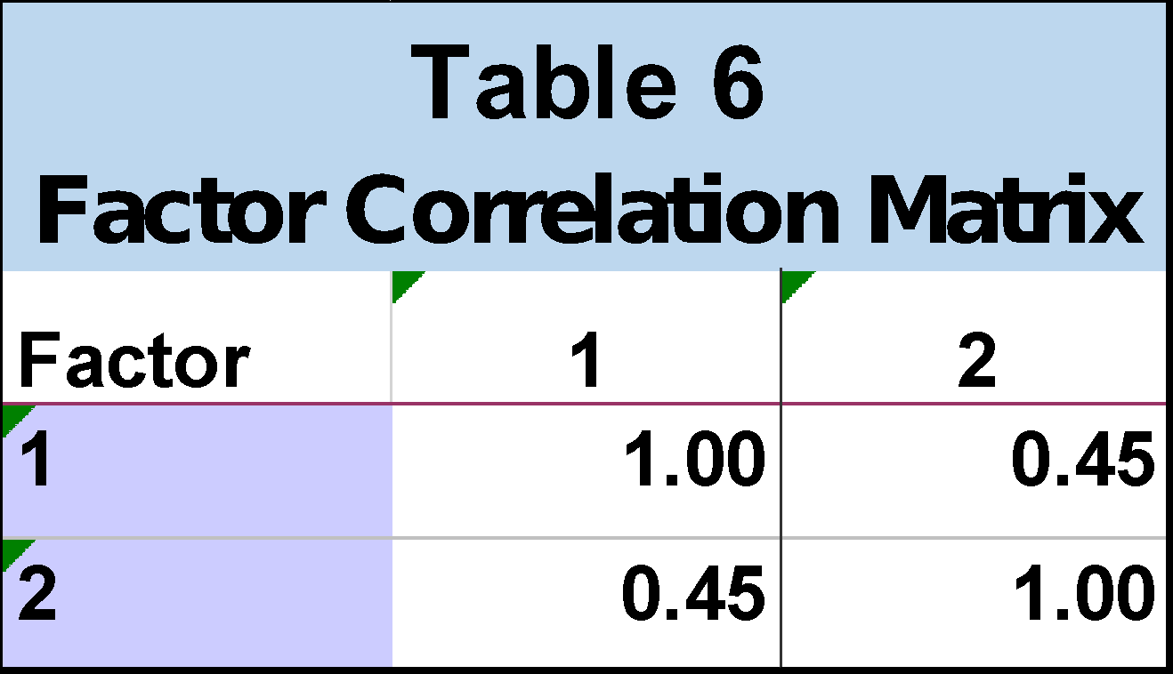

Based on the questions behind each factor, we named the Creativity factors as Business Efficiencies (Questions 1-5) and Patient Experience (Questions 8-10). The HR Factors are Unit Productivity Training (Questions 1-3) and Supervisor/Employee Engagement (Questions 4-6 & 11-12). Unit Productivity training questions involves the mandatory HR training which each employee undergoes when they are hired. Supervisor/Employee Engagement is a factor that describes the meetings and discussions which are focused on delivering an excellent service to all patients.

All the variances are greater than or close to 0.7, which tells us that the factors are convergent. Also, the average variance extracted by both factors is higher than the variance shared between them, there is evidence of discriminant validity. From the factor analysis, we can infer that the factors that influence Creativity are questions regarding Innovating Business Efficiencies and Improving Patient Experience. On the other hand, Unit Productivity Training and Supervisor/Employee Engagement influences HR Practices. Some suggestions for the employees are:

1. Managers should guide employees on how they can do their tasks more efficiently.
2. CEO’s should optimize training programs which induces more productivity and efficiency. Also, by guiding the managers on the meetings with their respective employees working under them.
3. Nursing home workers should focus on making sure the patients are comfortable and their basic needs are taken care of. Public policy officials can improve patient experience by keeping paperwork to a minimum.

# Regression Analysis

**Hypotheses Test**

We conducted following four Hypothesis test to determine which of the HR Practices factor influences Creativity factors. The Null Hypothesis and Research Hypothesis for each of the four tests are as follows.

1. **Test 1**:- **To check whether Unit Productivity impacts Business Efficiencies**
   * The first hypothesis we came across from our factor analysis is to check whether unit productivity training impacts the business efficiency in general. Since the p-value from our hypothesis test is (0.507) greater than 0.1, we failed to reject the null hypothesis.
2. **Test 2**:- **To check whether Supervisor/Employee Engagement impacts Business Efficiencies**

* The second hypothesis we developed based on our factor analysis is to check whether Supervisor/Employee Engagement impacts the business efficiencies. Here, the p-value from our hypothesis test is (0.087), which is less than 0.1, we have enough evidence to reject the null hypothesis.

***Table 7*** represents results of hypothesis test to determine impact of HR Practices factor on Business Efficiency.



1. **Test 3:- To check whether Unit Productivity Training impacts Patient Experience**

* The third hypothesis tests is to check whether Unit Productivity Training impacts the Patient Experience. Here, the p-value from our hypothesis test is (0.968), which is greater than 0.1, so we cannot reject the null hypothesis.

1. **Test 4:- To check whether Supervisor/Employee Engagement impacts Patient Experience**
   * The fourth hypothesis tests is to check whether Supervisor/Employee Engagement impacts the Patient Experience. Here, the p-value from our hypothesis test is (0.018), which is less than 0.1, so we have enough evidence to reject the null hypothesis.

***Table 8*** represents results of hypothesis test to determine impact of HR Practices factor on Patient Experience.



**Conclusion**

Our regression analysis resulted in our following conclusions:

1. Supervisor/Employee Engagement is significant factor (p=0.018<0.1) impacting Patient Experience. The coefficient is positive (0.169) which would indicate that higher Supervisor/Employee Engagement makes Patient Experience better.
2. Supervisor/Employee Engagement also impacts Business Efficiencies. (As it is statistically insignificant p = 0.087<0.1)
3. Unit Productivity Training does not affect Patient Experience as well as Business Efficiencies.
4. **Most Significant HR Practices Factor: Supervisor Employee Engagement**
   * Supervisor Employee Engagement HR Factor affects both the Creativity sub dimensions Patient Experience and Business Efficiencies.
5. **Least Significant HR Practices Factor: Unit Productivity Training**
   * Unit Productivity Training factor does not affect any of the creativity sub dimensions.
6. The coefficient for Supervisor/Employee Engagement is 0.169 meaning that for a **one unit increase in Supervisor/Employee Engagement, we would expect a 0.169-unit improvement in** **patient experience**.
7. The coefficient for Supervisor/Employee Engagement is 0.239 meaning that for a **one unit increase in Supervisor/Employee Engagement, we would expect a 0.239-unit improvement in** **Business efficiencies**.

# Recommendations

**For Managers:**

1. Managers and Supervisors should consider increasing meetings with employees to ensure improvement in patient experience.
2. Managers and Supervisors should keep encouraging employees by giving them constructive feedback on their ideas and also empower them in implementing their ideas, which brings innovative practices to improve patient satisfaction.
3. Managers meeting with their team or employees also helps in improving Business Efficiencies.
4. So, Managers and Supervisors should increase discussing various ideas of improvement in Business Processes with their employees.

**For HR:**

1. The HR training programs offered to employees do not enhance employee creative ideas that could be implemented to improve the patient’s experience. Also, these trainings doesn't help in improving efficiency of Business processes.
2. Results of survey shows that Managers meetings with employees are the most effective way to improve patient care and creating innovative methods to improve productivity in business processes.
3. HR Team should consider implementing constant feedback discussion procedure between employees and Supervisors (like weekly/monthly team meetings, or weekly one on one meeting between the supervisor and employee) to see improvement in patient experience and efficiency in business processes.

**For CEO:**

1. Shift the focus of HR training onto improving mentorship skills for supervisors and improving communication between supervisors & employees as supervisor-employee meetings bring more creative ideas for improving patient experience as well as increasing business efficiencies.
2. Company should continue investing money on improving Supervisor’s leadership and team management skills.
3. Should management insist on continuing HR training for unit productivity and cost control, we recommend seeking another training vendor.

**For Nursing Home Workers:**

1. Nursing home workers should continue to come up with new creative ideas to improve patient experience.
2. Management is receptive to their input and feedback to improve processes.

# Appendices

**Appendix A**

**Survey Questions**

### Creativity Questions:

1. Providing new ideas to generate revenue for the unit

2. Using innovative methods to enhance unit productivity.

3. Using new methods to lower unit costs through your work activities

4. Using new methods to do your job with fewer resources

5. Using new ways to be able to complete work tasks more efficiently

6. Using new methods to resolve patient complaints.

7. Suggesting new methods to solve patient care problems

8. Implementing new ideas to make a patient’s stay comfortable.

9. Providing new ways to satisfy the needs of each individual patient.

10. Implementing new ideas to increase interaction with patients or their families

**HR Practices Questions:**

1. Every year, employees are required to sign up for mandated training that emphasizes practices for improving unit productivity

2. Most training programs emphasize cost control in job-related decisions

3. New training programs to improve unit productivity are routinely developed

4. Supervisors frequently seek input from employees to implement unit changes

5. Employees help determine their own work schedules

6. Supervisors and employees frequently make joint decisions about how to enhance unit productivity

7. Most training programs are geared to help enhance unit patients’ satisfaction levels

8. Each year, employees are required to sign up for mandated training that emphasizes practices for enhancing the quality of medical care

9. New training programs to improve the quality of care are routinely developed

10. Employees regularly participate in hospital-sponsored attitude surveys

11. Employees can openly express their opinions about the quality of care provided on their unit, in various unit meetings and groups

12. Supervisors meet with employees on a regular basis to discuss issues related to patient satisfaction